**DIGITAL MARKETING ASSIGNMENT**

|  |  |
| --- | --- |
| **NAME:** | B**.** VARSHINI |
| **DEPARTMENT:** | B.E.COMPUTER SCIENCE AND ENGINEERING |
| **COLLEGE:** | DHANALAKSHMI SRINIVASAN INSTITUTE OF TECHNOLOGY, SAMAYAPURAM, TRICHY. |
| **NAANMUDHALVAM COURSE:** | DIGITAL MARKETING |
| **NM ID:** | **978AC184D091F2ABD8E49AEAD12716D4** |

**1. Create a blog or Website using Blogspot and Wordpress. Customize the theme design and post new article with 500 words**

<https://wordpress.com/view/voguecircles.wordpress.com>

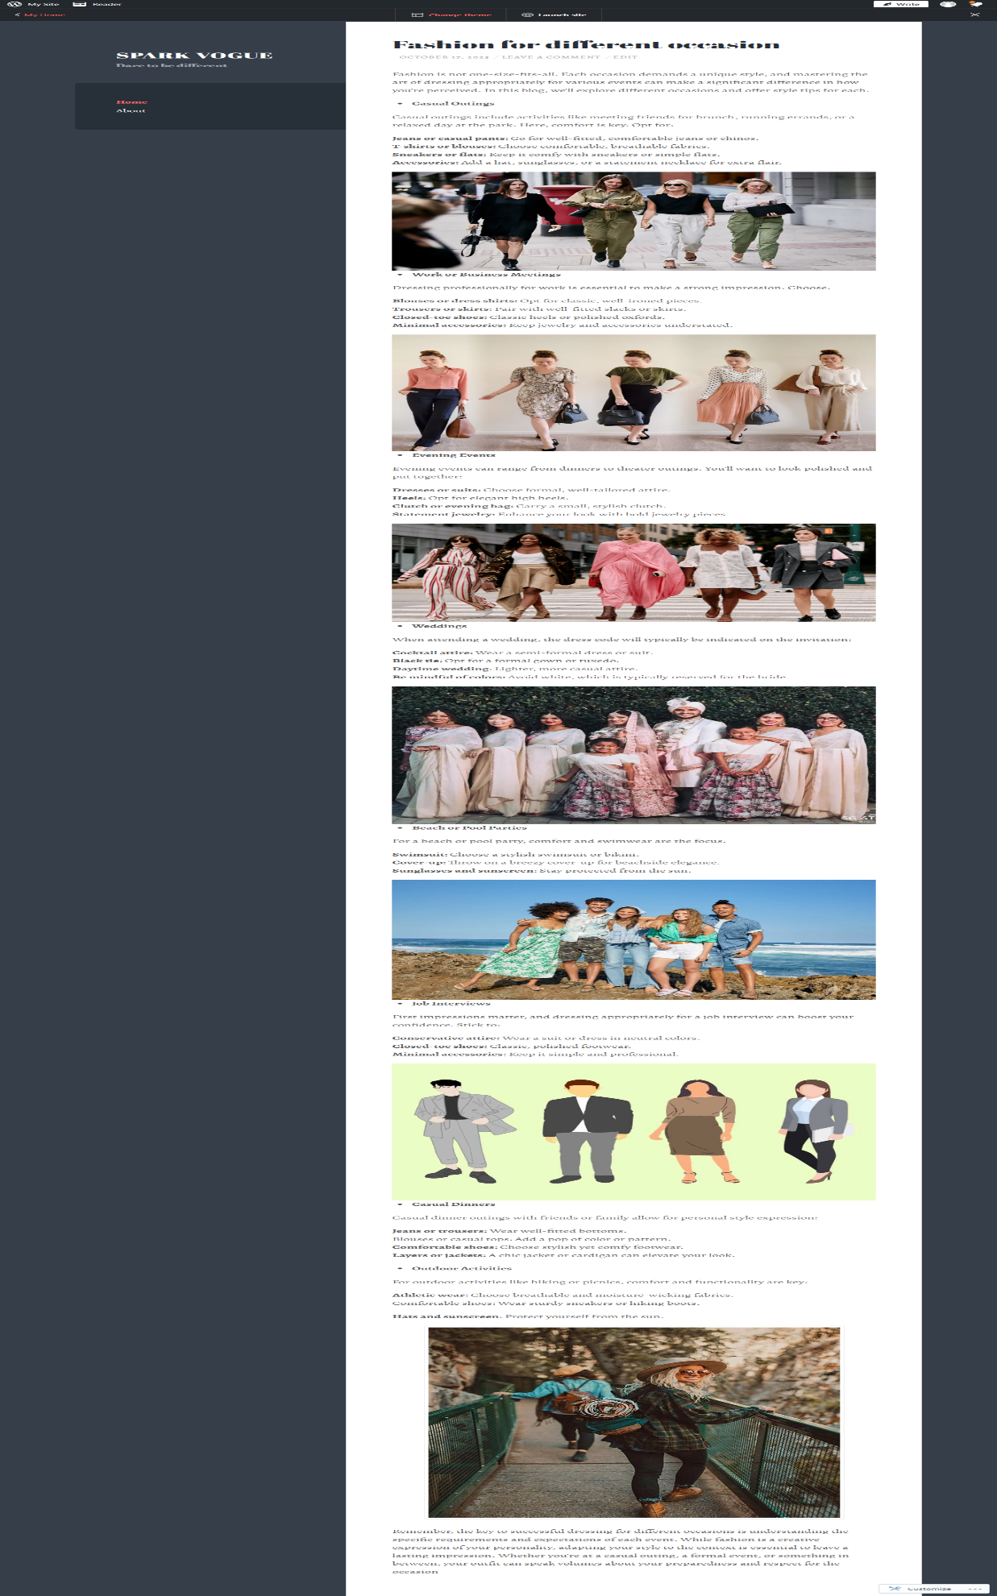

**2. Create a New Facebook Business Page and post one social media poster for**

**your brand.**

<https://www.facebook.com/sparkvoguecollections>

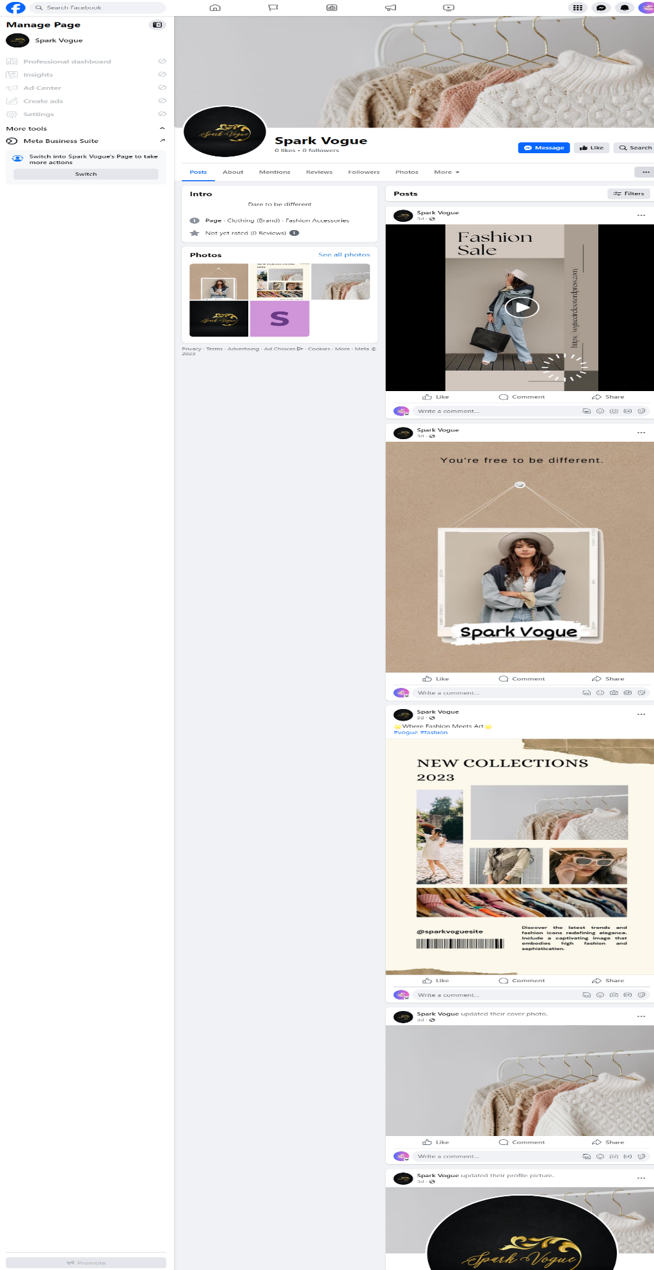

**3. Create and design a social media advertisement poster using canva**



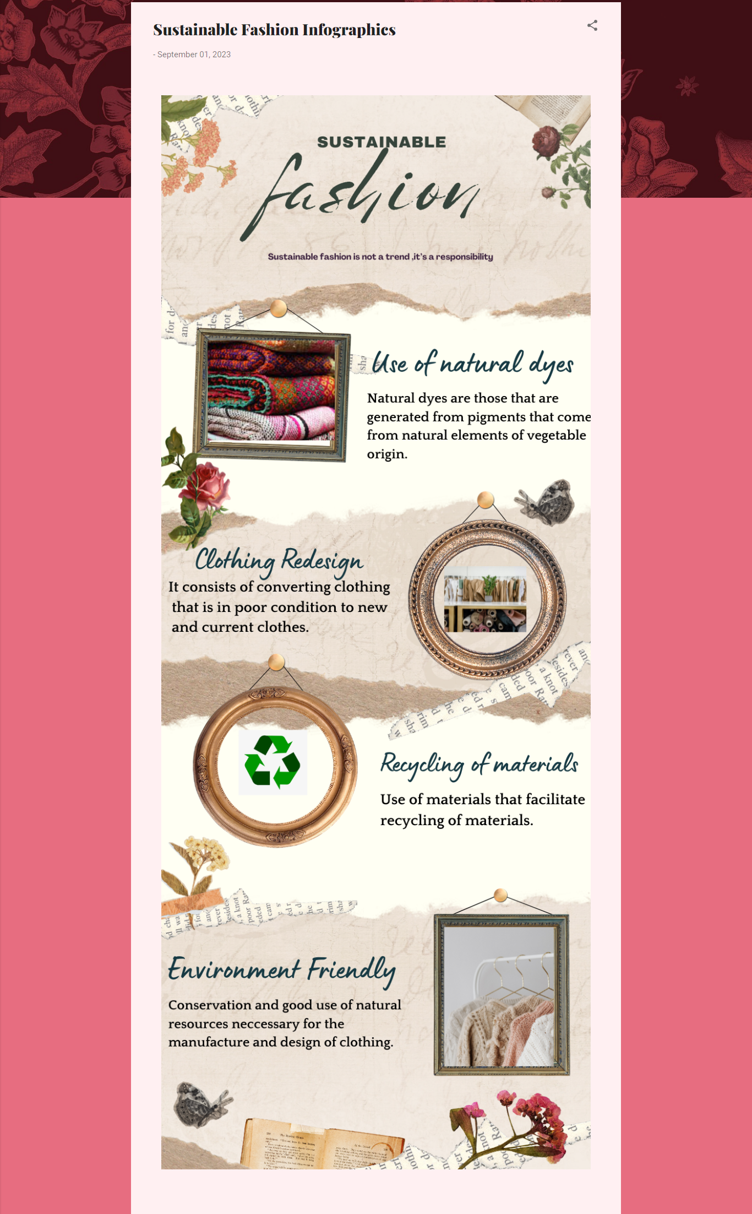

**4. Create email newsletter design using Mailchimp or canva tool.**

